**How to install maven on windows**

By Lokesh Gupta | Filed Under: [Maven](https://howtodoinjava.com/maven/)

[Maven](https://howtodoinjava.com/maven/) is a build and dependency management tool for Java based application development. Just like other Java based development tools, it is not installed as Windows service, rather it is configured using windows [environment variables](https://howtodoinjava.com/security/windows-7-set-environment-variables-without-admin-access/).

In this **maven tutorial**, I am installing maven on a **Windows 7 32bit** machine.

**Windows environment variables location:**  
Control Panel > All Control Panel Items > System > Advanced system settings > Environment Variables

Follow the steps needed to install maven on windows operating system.

**Step 1) Install JDK and Add ‘JAVA_HOME’ Environment Variable**

To install java, [download JDK installer](http://www.oracle.com/technetwork/java/javase/downloads/index.html) and **add/update the JAVA_HOME variable to JDK install folder.**

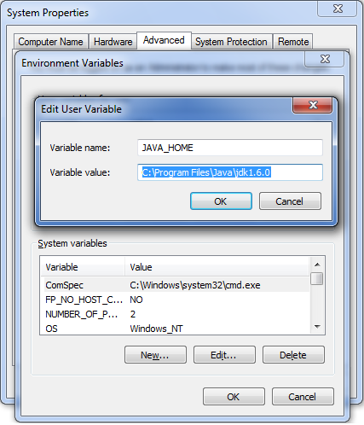

**Step 2) Download Maven and add ‘MAVEN_HOME’ and ‘M2_HOME’ Environment Variables**

Maven can be downloaded from this [**location**](https://maven.apache.org/download.cgi). I have extracted it in location – D:/Latest Setup/apache-maven-3.0.4. You can choose your own location.

**Set the M2_HOME and MAVEN_HOME variable to maven installation folder.**

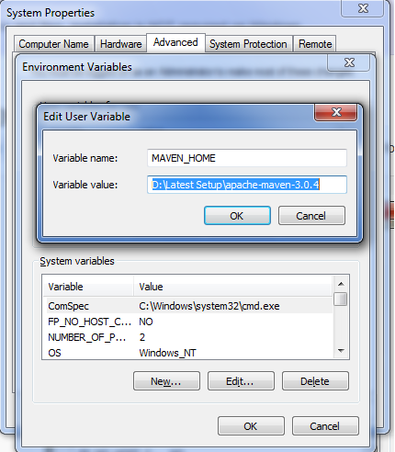

**Step 3) Include ‘maven/bin’ directory in ‘PATH’ variable**

**To run maven from command prompt, this is necessary. Update the PATH variable with 'Maven-installation/bin' directory**.

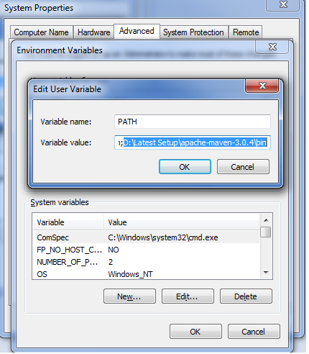

**Step 4) Verify maven in console**

Maven installation is complete. Now lets test it from windows command prompt.

1. Go to start menu and type cmd in application location search box.
2. Press ENTER. A new command prompt will be opened.
3. Type mvn -version in command prompt and hit ENTER.

|  |
| --- |
| Console |
| $ mvn -version |

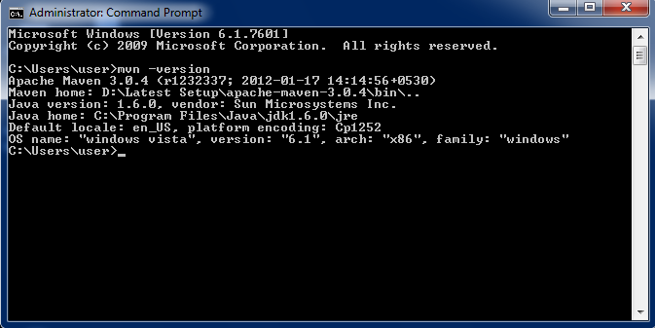

This should show the version information of maven installed. If there is any error shown, cross-check all above steps.

In this tutorial, we learned **how to install maven on windows**.

Happy Learning !!